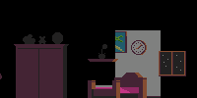room.png

Character starts in this area, a dark room at night. They can move left and right throughout the room and cannot run. Every time the character takes a step the walking.wav sound effect plays. roomTheme.wav the entire time on loop

->The ring.png effect comes out of the closet after 7 seconds and the ring.wav sound effect continuously plays on loop.

In order to progress the player has to go to the closet in the left corner and interact with it. When opened ClosetDoorOpen.wav plays.

->The initial image is darkcloset1.png. The player can select the other items in the closet by using the arrow keys. Such as when the left top item is being selected then darkcloset1.png is shown and when the player pressed left then darkcloset2.png is chosen since the cursor moves to the right.

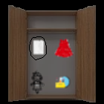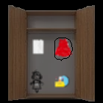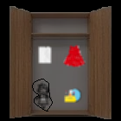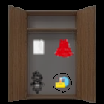

The player must select all items in the closet for the story to continue.

The top left item is the picture which when selected will show a picture(to be done soon) and display the dialog, diologue_room_doll1.png and when the player presses the interact button it will switch to diologue_room_doll2.png. If the item is selected again it will repeat the same sequence.

The top right item is the dress and will display diologue_room_dress1 then diologue_room_dress2.

The bottom left item is the doll and will display diologue_room_doll1 then diologue_room_doll2.

The bottom right item is the makeup and will display diologue_room_makeup1 then diologue_room_makeup2.

Once all items have been selected it will cut back to the room with the character in front of the closet and after 1 second the diologue_room_phone1.png will display then the diologue_room_phone2.png will display. The ring.wav sound effect will stop playing and then the diologue_room_phone3.png will display. After closing diologue_room_phone3.png The closet cannot be interacted with anymore and the player must interact with the bed to continue.

->Once the bed is interacted with the sleep1.png effect will appear over the bed. Then sleep2.png after 1 second and then sleep3.png after 1 second. Finally after 1 more second the screen will fade.